* Different ways of selecting elements using JavaScript and the DOM

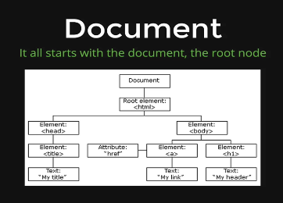

Our entire DOM all live in this document object

* Exercise

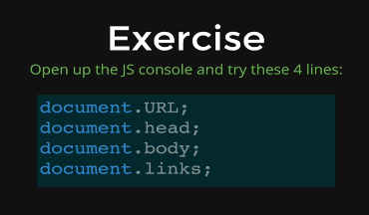

* + Document.URL;
    - Will show the URL of the website
  + Document.links;
    - Will show all the anchor tag(links) of the website
  + Document.body;
    - Will the body with every other element inside it
  + Document.head;
    - Will show the head
* Note
  + Everything about this video. We learn will always be
    - document.(something)

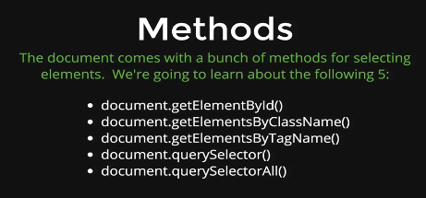

* Note
  + They are all already built-in
  + We can just type this in JavaScript

First Method

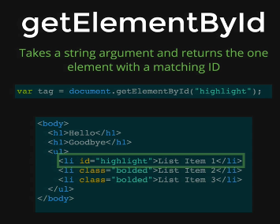

Second Method

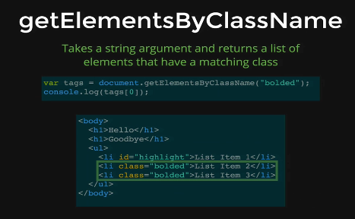

Third Method

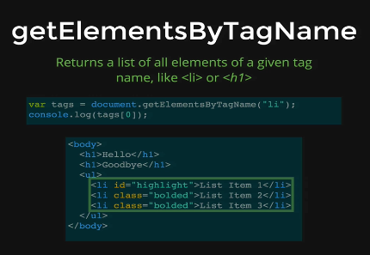

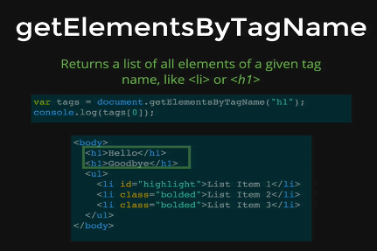

Fourth Method

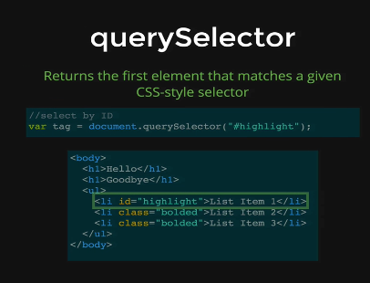

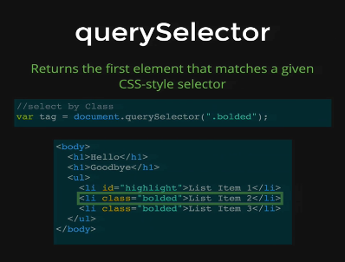

Fifth Method

